DEEP LEARNING PRACTICAL 7

**Saurabh Agarwal**

**J001**

**BTECH Data Science**

**3rd YEAR**

**J1 Batch**

**Aim :-**

How to get images from Image net part 2. **Observations :-**

The URLs used are –

1. [http://www.image-net.org/api/text/imagenet.synset.geturls?wnid=](http://www.image-net.org/api/text/imagenet.synset.geturls?wnid)
2. <http://www.image-net.org/api/text/imagenet.synset.geturls?wnid=n04194289%22>

The images from the site are downloaded.

2 directories are created to store these images. The images used are of cats and dogs.

After the images are saved in the folder, a dataframe is created. Similar dataframe is created for test.

The images are passed through a generator function for both train and validation sets.

A Sequential model is created with 6 layers.

The 6 layers are conv2D, flatten, dense, relu, dense,sigmoid.

The model is then evaluated and a roc_auc_score is generated.

The output is predicted. AUC validation score – 0.9134

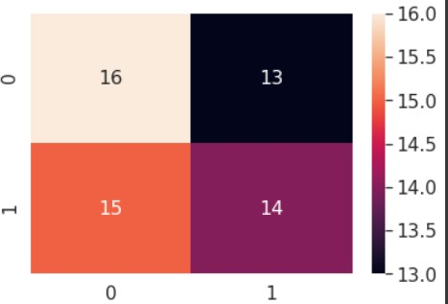

The link of the collab sheet where the code was run –

<https://colab.research.google.com/drive/12LMUQdewQeiHH9CzS1BvuZy4UvBBTMxX#forceEdit=tru> [e&sandboxMode=true&scrollTo=Lz42zfTtkKKQ](https://colab.research.google.com/drive/12LMUQdewQeiHH9CzS1BvuZy4UvBBTMxX#forceEdit%3Dtrue%26sandboxMode%3Dtrue%26scrollTo%3DLz42zfTtkKKQ)

**Conclusion** :-

30 observations have been classified correctly.

28 observations are misclassified